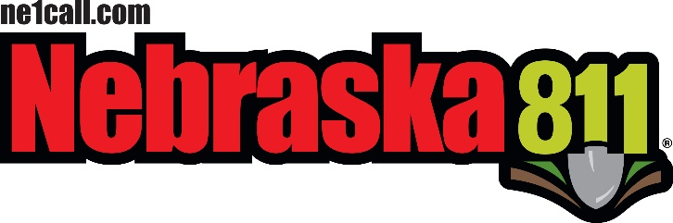
STATEWIDE ONE-CALL NOTIFICATION CENTER
BOARD OF DIRECTORS BOARD MEETING AGENDA

April 18, 2019
Location:
Country Inn and Suites
5353 N 27th Street
Lincoln, Ne. 68521
Committee Meetings: 9:00 am Board meeting: 9:30 am

- Call Meeting to Order
  - Housekeeping -
  - Meeting Notice posted –
  - On the Web –
  - Announcements -

- Roll Call

- Introductions
  - Guest’s introductions

- Approval of Meeting Agenda

- Approval of Minutes of the previous Meeting
  - February 21st Board meeting in Omaha

- Committee Reports
  - Policy Committee
    - Dave S.
      - Chapter 1 & 2 on Rule & Reg Changes – Status
      - A new hearing date set yet.
      - Time Frame to allow UG Operators to be compliant with Rules and Reg. Chapter 1 & 2 when it becomes Approved and Final.
      - Communications with Excavators about changes
      - Damaged Private Facilities – Policy Committee update
      - Information on items being looked at for the next changes to Best Practices
    - ACTION ITEMS:
      - LB462 Progress – Policy Committee

  - Legislature Committee
    - Andy – LB 462
    - Status on LB 462 – Committee Priority Bill
    - ACTION ITEMS:
      - Board position on LB462 – Val and others

  - Advertising Committee
    - ACTION ITEMS:
      - TBD
  - Bylaws Committee
    - ACTION ITEMS:
      - By law update

- New Committees - Val
  - Best Practices committee -
  - New Technology committee -

- DPRC Center Report
  - DPRC Status Report – Tyler
  - Outreach Report – Jill
    - 2019 Stakeholders Meetings Schedule – Val
    - Questions for Jill
    - ACTION ITEMS:
      - Outreach on MEPR – All, Call Center
      - Non–Response automation and billing after MEPR goes into effect
      - Stakeholder Meeting Topics – Jill & Val

- Treasurer’s Report
  - John’s Report
  - Approval of the Treasurer’s Report
  - Questions / Concerns
  - ACTION ITEMS:
    - TBD

- State Fire Marshal’s Report
  - David’s Update – Combining the One Call Grant and the Damage Prevention Grant – (Status)
  - Kevin’s Report and Meeting dates for 2019
  - Regina’s Updates
  - Questions / Concerns for David, Kevin or Regina
  - ACTION ITEMS:
    - Title 155 Amendment Status & BOD reappointment Process – NSF Office
    - 2018 PHMSA audit results to board – David

- Non-Compliance Report – Ne. AG’s Office
  - Report from NE. State Fire Marshal’s Office
  - ACTION ITEMS:
    - 1st Quarter AG Report – Milissa

- Old Business
- Auto Non-Response with MEPR / Electronic Positive Response
- Company Phone # on Tickets for Excavators (Leaks due to hits on Hazardous / NG Pipelines
- CGA Underground Safety Summit and Conference- Tampa
- Adding some Committees – (Finance Committee, Best Practices Committee, etc.)
- Board of Director meeting schedule – Val
- Public Comment follow up - Val
- ACTION ITEMS:
  - TBD

- New Business
- Blizzard, Flooding and Ice Damage to UG Facilities (Tel – Com, Power Districts, Transmission Pipelines, Roads and Bridges,

Local Distribution System both Gas and Electric)
- Personal Damages
- Helping Flood or blizzard folks impacted by the storms
- Legal Counsel hiring – Val and others
- ACTION ITEMS:
  - TBD

- Common Ground of Nebraska Report
- CGN Updates
- Next CGN Meeting –

- Public Comment (Questions and or concerns)

- Closing Comments from the Board Chair

  - The next big storm

  - Next meeting date and site – June 13th in Grand Island with location TBD

- Adjournment

The public may request that items be added to the Agenda if such requests are received 24 Hours prior to any scheduled meeting. Requests must be in writing and directed to:

Val Snyder, NE811 Board Chairperson; 3808 28th Ave. Suite B. Kearney, Nebraska 68845
Or

E Mail to – val.snyder@tallgrassenergylp.com

